HOMEWORK WEEK2 - Revision App Group 2
Esther Makinde, Linsay O’Hare, Rebecca Sewell and Louise Anderson

This week’s homework will be purely Project based. You need to work as a group and the homework will be submitted by one of the members of your group. List the other members of your group in the document, so that your instructor can mark every student.

- Your group needs to decide what kind of project you are going to work on and lock in your decision.
- You need to submit a free style paper that describes your project on a high level. Please cover the following questions:

- What are you building? We are building a revision app using a combination of Python, APIs and Flask. This is an example of the log in page:
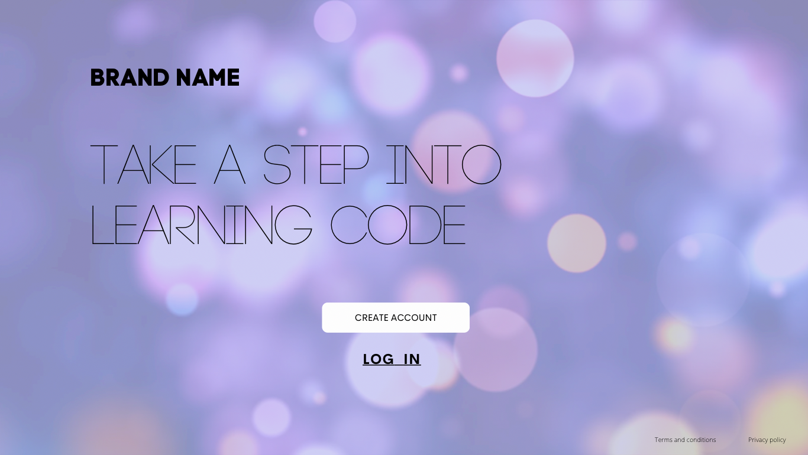

- What does it do or what kind of problem does it solve? The app allows the user to revise different programming languages and concepts in manageable chunks of information.
- What are key features of your system? The revision app will have a log in, display the progress of the learner, make note of incorrectly answered questions and redisplay them to the user to cement their learning. For example:
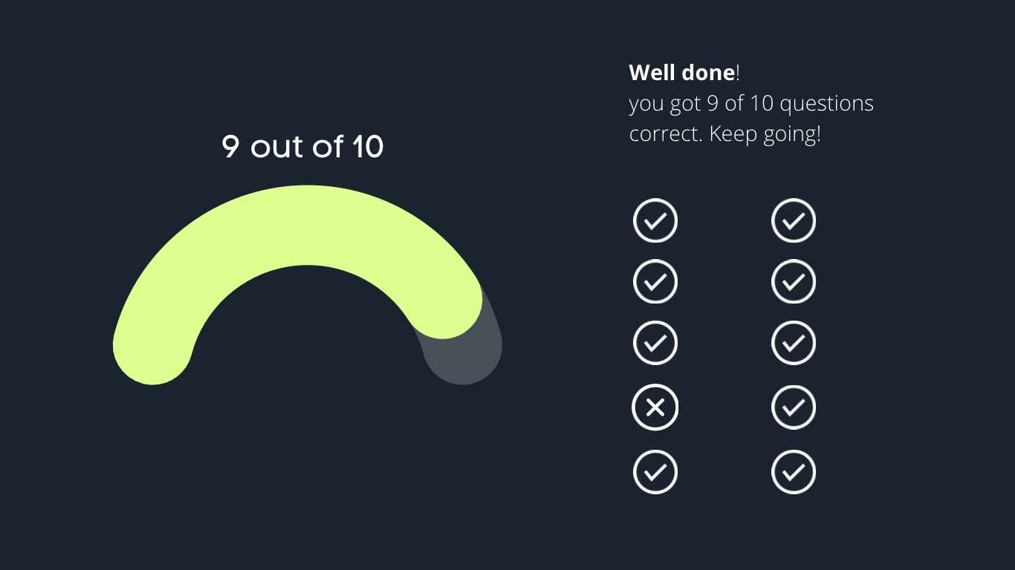

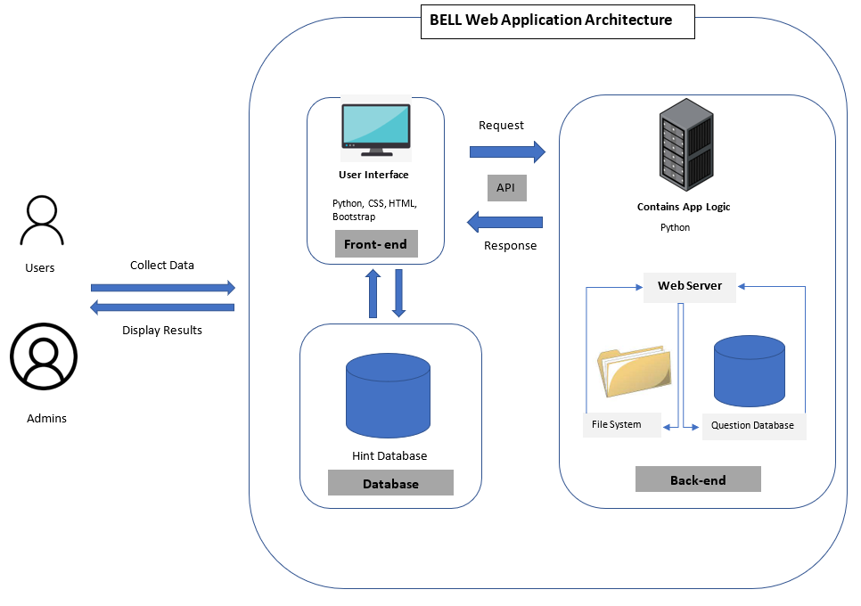
- Provide a sample architecture diagram of your system (you can use PPT with squares and circles to demonstrate a simplified flow of your system) For example:

- Describe the team approach to the project work: how are you planning to distribute the workload, how are you managing your code, how are you planning to test your system.

We discussed project ideas and pre-existing skills so each group member has tasks they feel confident with. Esther has created a google doc with the project outline and resources plus parts of the front end for the login pages (mostly taken from bootstrap). She has also created the forms for the login and sign up info and is researching database creation so that our user info can be stored. Rebecca has created our Git repository, which is at the following address: https://github.com/ginkoding/CFG-Revision-App-Group-2/branches
and a Notion project division board Task Board | Tasks (notion.so) plus mock-ups of completed pages (displayed earlier in the document).
As well as having previous experience with HTML and C, Linsay has created google docs for homework and diagram and image research. As a group, the code and project files are being managed with Git in developing branches that are then merged to avoid conflict.

Project Deadline: 13th/14th August 2022.

